IFG Explore 1st Year
Term One, Week Eight Special Awardz Night
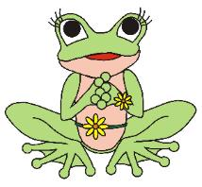

Aim: Organise a FROG night Fully Rely On God
"Trust in the Lord with all your heart..." Proverbs 3:5-6

The idea is that everything you do throughout the programme is somehow related to green and frogs. The girls will come dressed in green, and you can decorate the hall with green balloons, green streamers, green lights and green for anything else that you can think of. This helps get your group in the mood right from the very beginning.

As it is your Special Awardz night, you can either invite parents and families for the whole evening, or get them to come for the last ½ hours.

Devotions:
Message: Let God help you deal with your problems.
Choose a passage or passages from the suggestions below for your devotions:
Be a FROG! Rely on God!
- Trust in the Lord with all your heart... Proverbs 3:5-6
- Casting all your care upon him; for he careth for you. 1 Peter 5:7
- Come unto me, all that labour and are heavy laden, and I will give you rest. Matthew 11:28
- I have told you these things, so that in me you may have peace. In this world you will have trouble. But take heart! I have overcome the world John 16:33
- For it is by grace you have been saved, through faith and this not from yourselves, it is the gift of God not by works, so that no one can boast. Ephesians 2:8-9
- Take my yoke upon you, and learn of me; for I am meek and lowly in heart: and ye shall find rest unto your souls. For my yoke [is] easy, and my burden is light. Matthew 11:29-30

Here are some ideas for activities for this night:
Crafts:
Make frog rocks:
Collect up some frog size rocks that the girls can paint green, you may decide to paint these yourself so they are dry for the girls to make into a frog. Glue some large wiggle eyes on and use a piece of red pipe cleaner for its mouth. Cut webbed feet (in one piece) out of green fun foam and glue the feet to the bottom on the stone.
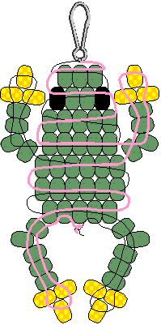
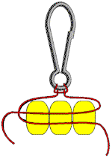
Frog made from Beads:
You need:
Beads – 50 green, 12 yellow, 2 black.
2 metres of satin cord and 1 lanyard hook.
Fold your cord in half to find the centre. Use a half hitch (see detail above) to secure it to lanyard hook. Lace beads using pattern at right as a guide. Finish by tying off with a double knot.

Games:
Balloon Race:
A game that you can try on this night is to give each team a balloon and everyone on the team has to run around an obstacle course with a green balloon between their legs. This can be as long or short as you want it.

Pass the frog:
Each team needs two plungers (Plumbers plunger). Teams must pass a green water-filled balloon from plunger to plunger without dropping the balloon. You can put frog features on the water balloon. If they drop the balloon, they start over again. First team finished with their balloon still in tack in the winner.

Play “tadpole, tadpole, frog” – like “duck, duck, goose”.

Toss the frog:
Take a plastic swimming pool and make floating lily pads. Have the girls throw lightweight plastic frogs and try to get them on the lily pads to score points.

Leap frog sack race:
Get some sacks that the girls will fit into, attach a cardboard cut out of a frog to the sack. Put the girls into teams and have a sack race.

Catching flies:
See who can catch the most flies by tossing raisins up and catching them in their mouths.

Supper:
Have everything green. Green cakes, pikelets, jelly, biscuits with green icing, drink green cordial out of green cups – let your imagination run wild.
Invite the parents and families to share in this part of the programme if they haven’t been to the whole evening.

Present the girls with their badges, making this a special time for them.

Close in prayer.

Home time.
Notice - share with them what they will be doing in IFG after the holidays.

